**Week 2 & 3**

1. **Do the MATLAB online ONRAMP course (if u have done it already do the next course) .**
2. **Assignments should be submitted before this Sunday (04.06.2023). More details will be shared later.**

**Assignment 1**

1. The Gambler's Ruin Problem

Suppose a gambler starts with an initial fortune of a dollars and repeatedly plays a fair game where, in each round, the gambler wins or loses one dollar with equal probability. The gambler continues playing until either they reach a target fortune of b dollars or they go broke (i.e., reach zero dollars). What is the probability that the gambler reaches the target fortune before going broke?

1. In a room of n people, what is the minimum value of n such that there is a greater than 50% chance that at least two people share the same birthday? Assume that each person's birthday is equally likely to fall on any day of the year (ignoring leap years).
2. A target is made of three concentric circles of radii 1 / $\sqrt{3}$, 1, $\sqrt{3}$ feet. Shots within the inner circle give 4 points, within the next ring 3 points and within the third ring 2 points. Shots outside the target give 0. Let be the distance of the hit from the centre (in feet) and let the p.d.f. of be

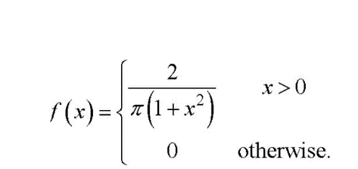

What is the expected value of the score in a single shot?

1. A machine contains two belts of different lengths. These have times to failure which are exponentially distributed, with means α and 2α . The machine will stop if either belt fails. The failures of the belts are assumed to be independent. What is the probability that the system performs after time α from the start?